**PRACTICAL NO. 02**

* **Addition of vectors :**

Code:

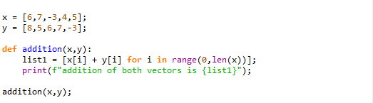

Result:



* **Scalar multiplication to vector :**

Code:

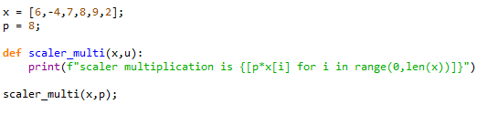

Result:



* **Dot product of vector :**

Code: 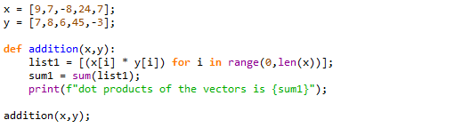

Result:



* **Basic types of vectors** :
* Column vector :

Code:

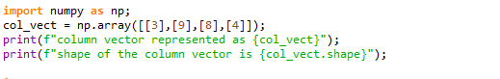

Result:

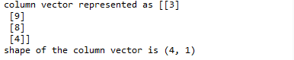

* Row vector :

Code:

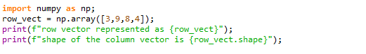

Result:



* **Zero vector :**

Code:



Result:



* **Operations on vector using numpy array** :
* Addition & subtraction :

Code:

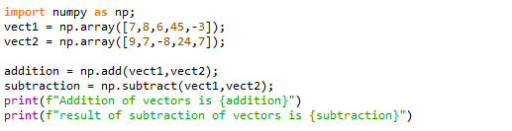

Result:



* Scalar multiplication :

Code:

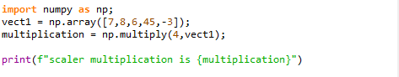

Result:



* Dot product :

Code:

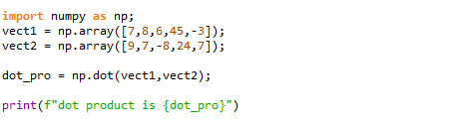

Result:

